North-Central Idaho Speakers Bureau
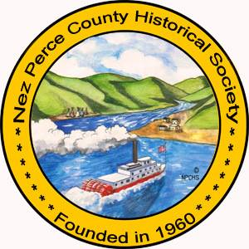
A Program of the Nez Perce County Historical Society and Museum
HOST ORGANIZATION EVALUATION FORM

____________________________________________ _____________________________________________________
Hosting Organization Contact Name

__(___)_________________________ _________________________________
Phone Number Email Address

_____________________________________________________________________________________________________________
Hosting Organization Mailing Address City State Zip Code

_________________________________________ ____________ _________ _________________ _________
Speaker Date Time Attendance (Adults) (Students)

On a scale of 1 (low) to 5 (high), please rate the following:

The audience enjoyed the presentation 1 2 3 4 5
The audience learned something about the topic 1 2 3 4 5
The audience seemed interested in the topic 1 2 3 4 5
The topic is what I expected 1 2 3 4 5
I was satisfied with the overall presentation 1 2 3 4 5
I would recommend this speaker to other organizations 1 2 3 4 5

Please feel free to provide suggestions/additional comments:
__________________________________________________________________
__________________________________________________________________
__________________________________________________________________
__________________________________________________________________
Please return completed form to:
Nez Perce County Historical Society
0306 3rd Street
Lewiston, Idaho 83501
Or by email to npchsdevelopment@gmail.com

