Event Equipment Rental Form
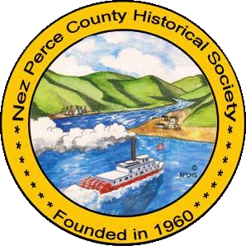

We are happy to be a part of your event and are excited to help make it happen. Please complete this form for our records. By signing this form you are acknowledging that any items lost or broken will be your responsibility to replace in a timely manner. If there are complications with any of the equipment you are using please give us a call and let us know.

The event items you are using were donated to the Nez Perce County Historical Society by Lewis Clark Recyclers. Your $150.00 per event day suggested donation for using these items will support the properties and programs of the Society.

Please check which equipment you will be borrowing and how many of each you are taking. The amounts listed are the replacement costs, not the total owed today. Please see attached pages for the liability waiver form to review and sign.

Chairs: X’s_____ $20.00/ea.

Tables: X’s_____ $150.00/ea.

Trailer: _____ $3,000

_______________________________________
Name of Renter:

_______________________________________
Organization/Company Name:

_______________________________________
Renter’s Phone Number:

_______________________________________
Renter’s Signature:

_______________________________________
Equipment Return Date:
_______________________________________
Date of Rental:

_______________________________________
Date(s) of Equipment Usage:

_______________________________________
Address of Event:

_______________________________________
NPCHS Employee Signature:

____________________________ __________ ___________________________ _________
Returned by Renter’s Signature: Date: Received By NPCHS Signature: Date:

(208)743-2535 | 0306 3rd St. Lewiston, ID 83501 | Tues. – Sat. 10:00 a.m. – 4 p.m.

