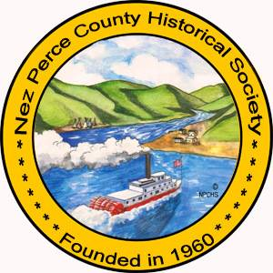 Reimbursement & Payment Form for speakers
IN-KIND MATCH FOR TRIP
TRAVEL
Time | ____hours x $10.00=$_________
PREPARATION
Time | ____ hours x $10.00=$_________
Copies, equipment, etc. | $_____________
TOTAL IN-KIND | $_____________

Please return the completed
form to:

Nez Perce County Historical Society
0306 3rd Street
Lewiston, Idaho 83501

TRAVEL
Note: Travel expense are only applicable when a speaker is traveling outside of the Lewis-Clark Valley and is approved prior to an event. Only honorarium will be paid for events without the LC Valley
Mileage | ______miles x $0.54 = $________
MEALS
Breakfast | ______meal(s) x $7.50= $______
Lunch | ______meal(s) x $7.50= $______
Dinner | ______meal(s) x $7.50= $______
LODGING:
Hotel/Motel | ______day x $65.00 = $ _______
TOTAL TRAVEL EXPENSES: | $_________________

** Original receipts
with business name are
required for
reimbursements.

Official Use Only
DO NOT WRITE HERE

Received:
Paid:
Check #:
_________________

HONORARIUM (please check one)
0-100 Miles Round Trip | $125.00_____
101-199 Miles Round Trip | $150.00_____
200+ Miles Round Trip | $175.00_____
TOTAL HONORARIUM | $_____________

Title or Topic of Presentation_____________________________________________Date________________________
Engagement Location___________________________________________________
Host Name____________________________________________________________
Signature of Speaker_____________________________________________________Date______________________
Print Name_____________________________________________________________
Total Number in Attendance Students_________ Adults_____________
Additional Notes_________________________________________________________________________________

